This file includes an activity video form and a template for video analysis submitted to CMC-AP2017.
Note: During your first submission, please remove author information including author name(s) and affiliation(s); After your submission is accepted and you are submitting a camera-ready version, please then provide author information. This will help us run smoothly the blind evaluation of submission. Thank you for your cooperation.

Please remove this sentence and the sentences above in your submission.

Descriptions of micro-analysis and discussion of activity videos

Author information
Name(s): |  | Affiliation:
Mobile: |  | Email:
Video format
File Name: |  | Format(AVI, MPEG etc.):
File Size: |  | Time duration:
Required Player: |  | Note:
Contents and main points
What is the video about? | In texts and concept maps
What are the intended questions that you want to discuss using this video | In texts and/or concept maps
What are your opinion to the above questions that you want to discuss | Your own answers or further questions
Video Analysis Report for cmc
Jinshan Wu¹, Jin-Xin Hao²
1 Beijing Normal University, Beijing, 100875,China
2 Beihang University, Beijing, 100191,China
Email: jinshanw@bnu.edu.cn, hao@buaa.edu.cn

Abstract: This is an abstract.

A concept map of the main contents of this submission:

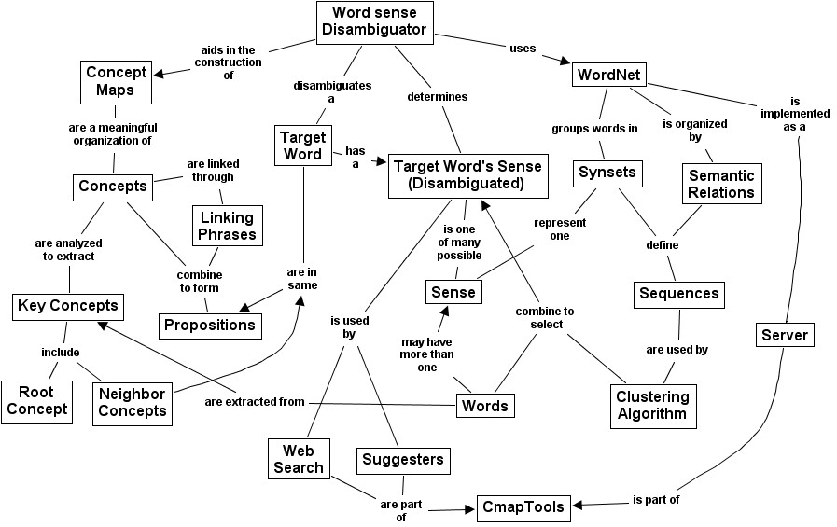

Introduction
You might want to shortly describe the problem and some background. In order to do so, you might need some references such as Novak, J. D. (1998) or Novak, J. D., & Gowin, D. B. (1984).
We strongly suggest you to explicitly state the main questions, lessons in this section.

What is in the video
In reasonable detail.

Subsections

subsubsections

Why we want to do it in this way and why we want to present this at CMC-AP2017
And what you want to discuss via presenting this video.

Acknowledgements

References
Novak, J. D. (1998). Learning, creating, and using knowledge: Concept Maps as Facilitative Tools in Schools and Corporations. Mahweh, NJ: Lawrence Erlbaum Associates.
Novak, J. D., & Gowin, D. B. (1984). Learning How to Learn. New York: Cambridge University Press.

