This file includes a template for innovative experiences report submitted to CMC-AP2017.
Note: During your first submission, please remove author information including author name(s) and affiliation(s); After your submission is accepted and you are submitting a camera-ready version, please then provide author information. This will help us run smoothly the blind evaluation of submission. Thank you for your cooperation.

Please remove this sentence and the sentences above in your submission.

A report of innovative experiences for cmc
Jinshan Wu¹, Jin-Xin Hao²
1 Beijing Normal University, Beijing, 100875,China
2 Beihang University, Beijing, 100191,China
Email: jinshanw@bnu.edu.cn, hao@buaa.edu.cn

Abstract: This is an abstract.

A concept map of the main contents of this submission:

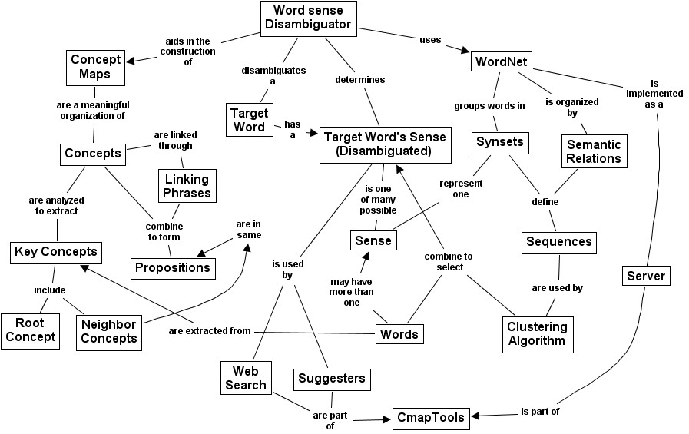

Introduction
You might want to shortly describe the problem and some background. In order to do so, you might need some references such as Novak, J. D. (1998) or Novak, J. D., & Gowin, D. B. (1984).
We strongly suggest you to explicitly state the main lessons and experiences in this section.

What we have done
In reasonable detail.

Subsections

subsubsections

What can we learn from it
And why you want to share this with us together.

Acknowledgements

References
Novak, J. D. (1998). Learning, creating, and using knowledge: Concept Maps as Facilitative Tools in Schools and Corporations. Mahweh, NJ: Lawrence Erlbaum Associates.
Novak, J. D., & Gowin, D. B. (1984). Learning How to Learn. New York: Cambridge University Press.

